**UNIT-I**

**CHARACTERIZATION OF DISTRIBUTED SYSTEMS**

1. Define Distributed System & discuss its characteristics. Give examples for Distributed Systems.

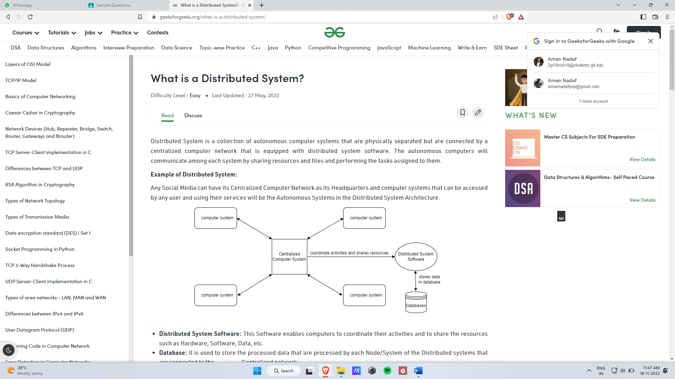

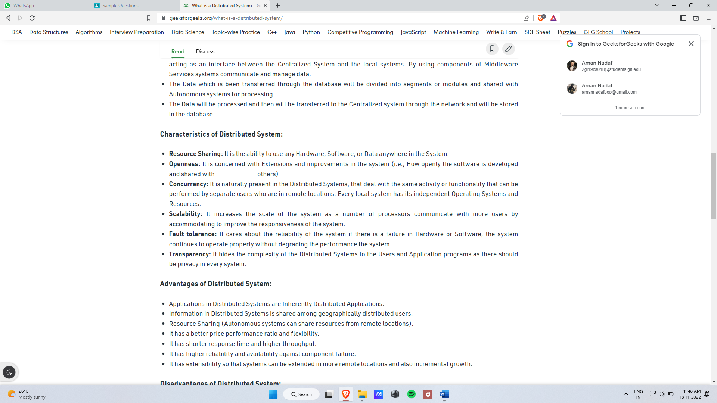

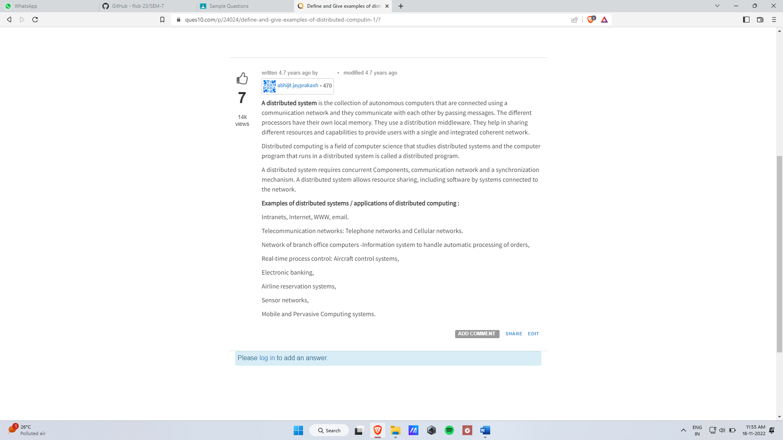

1. List the challenges in distributed systems. Explain in detail any two of them.

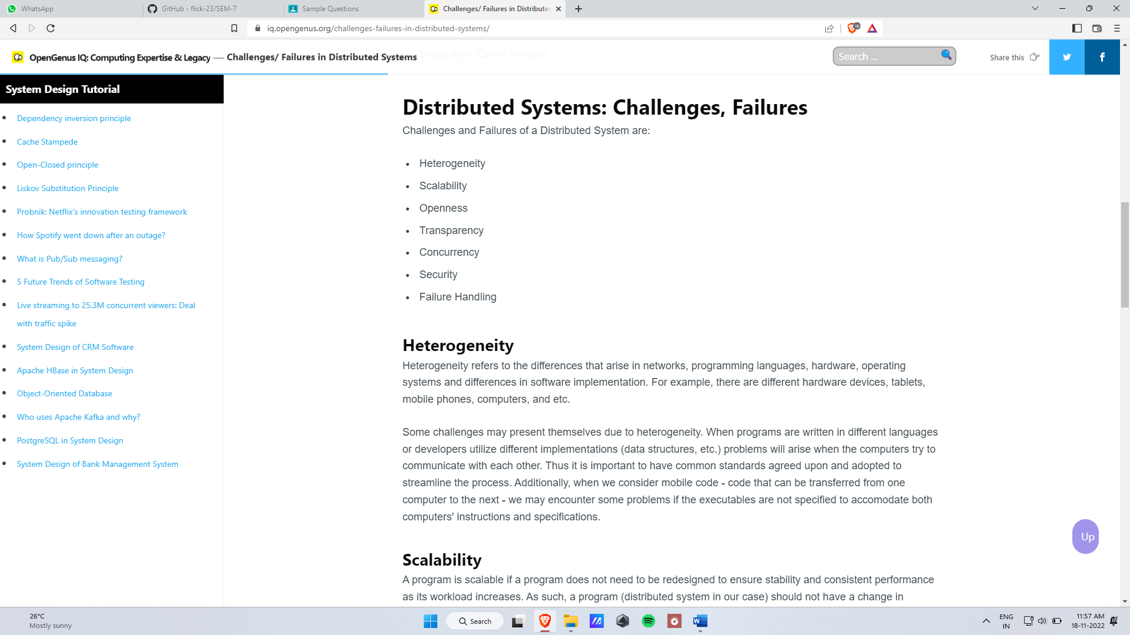

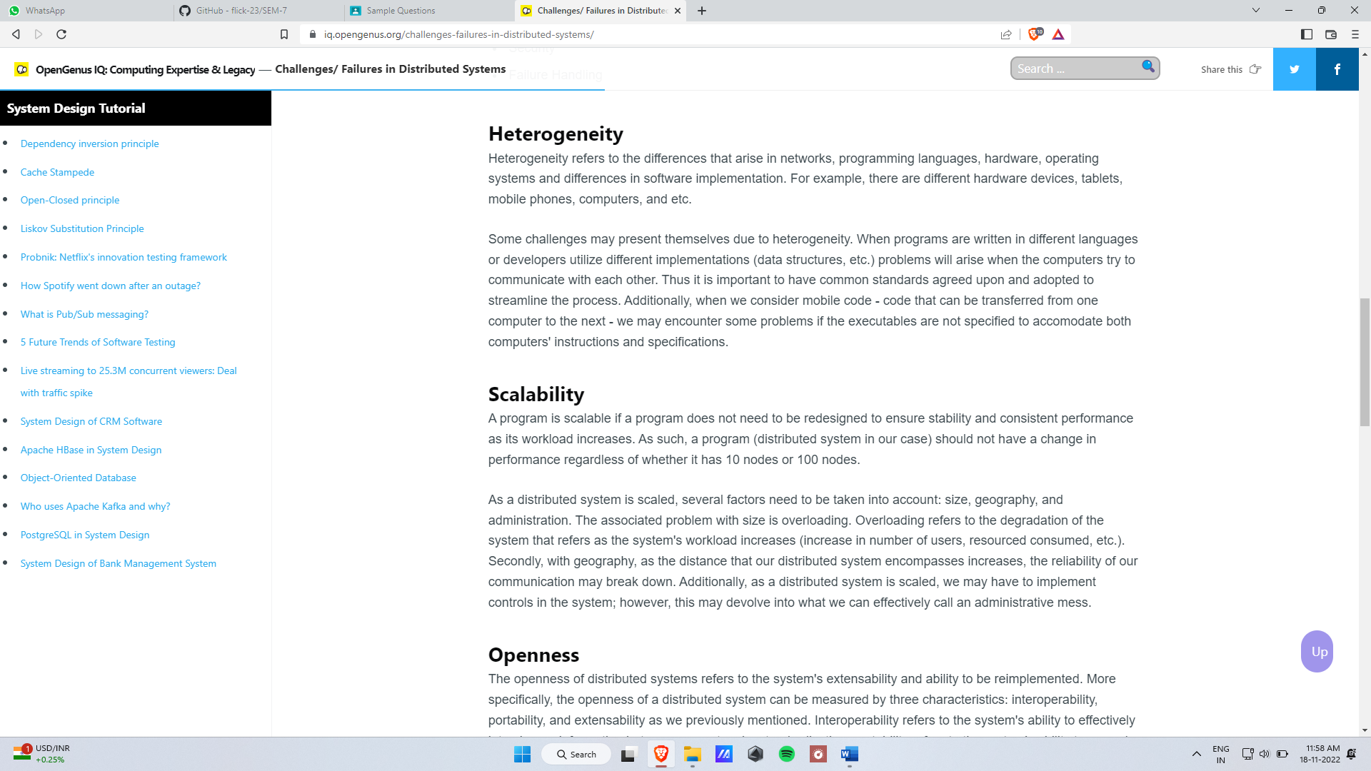

**3>Synchronous and Asynchoronous in DC**

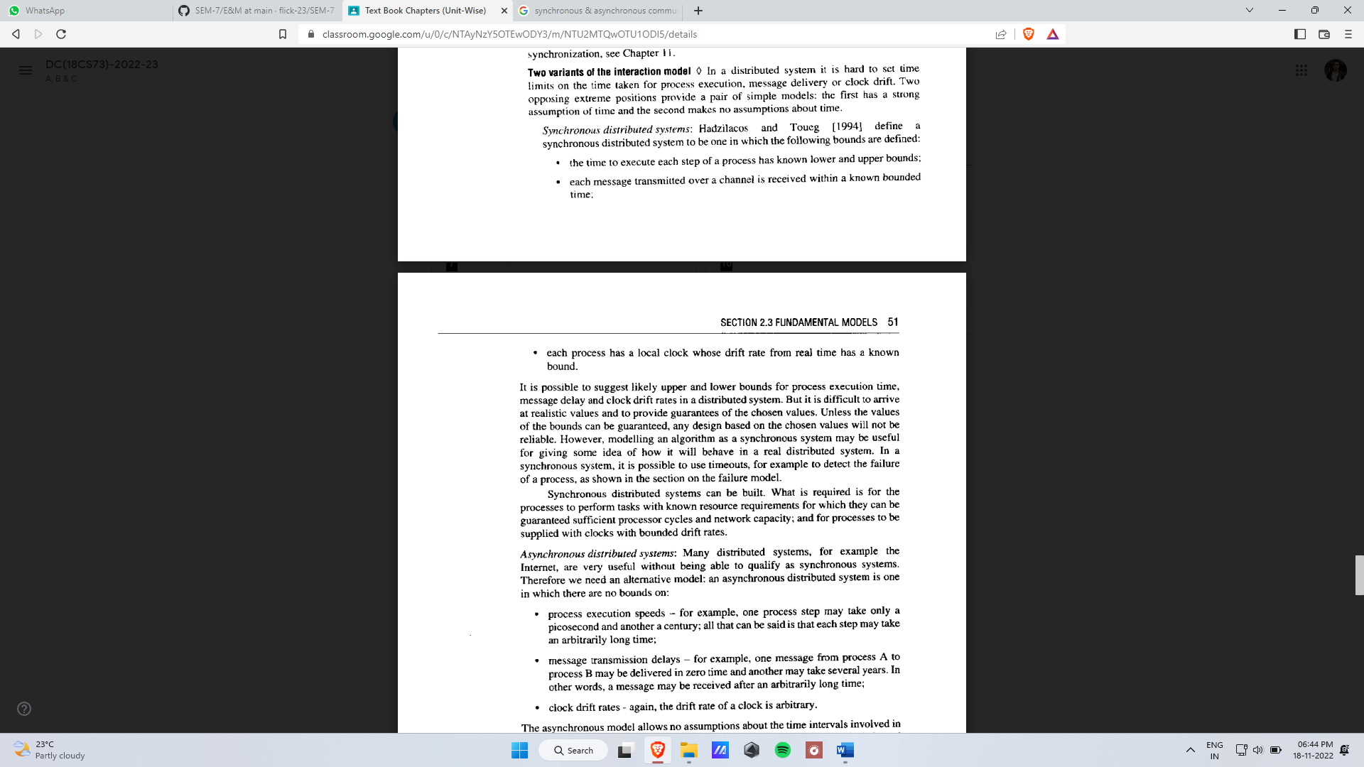

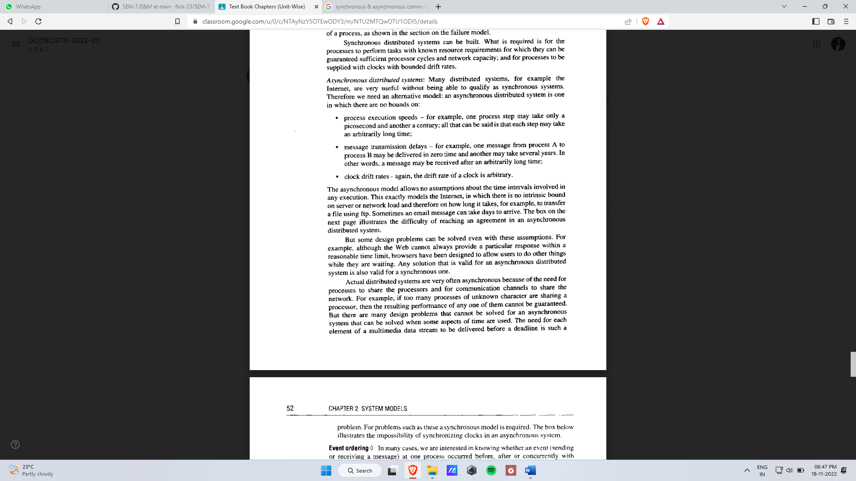

**SYSTEM MODELS**

1. Define Architecture Model. Mention its goal & explain the following with an example.

i) Mobile Code ii) Mobile Agent iii)Proxy Server & Cache

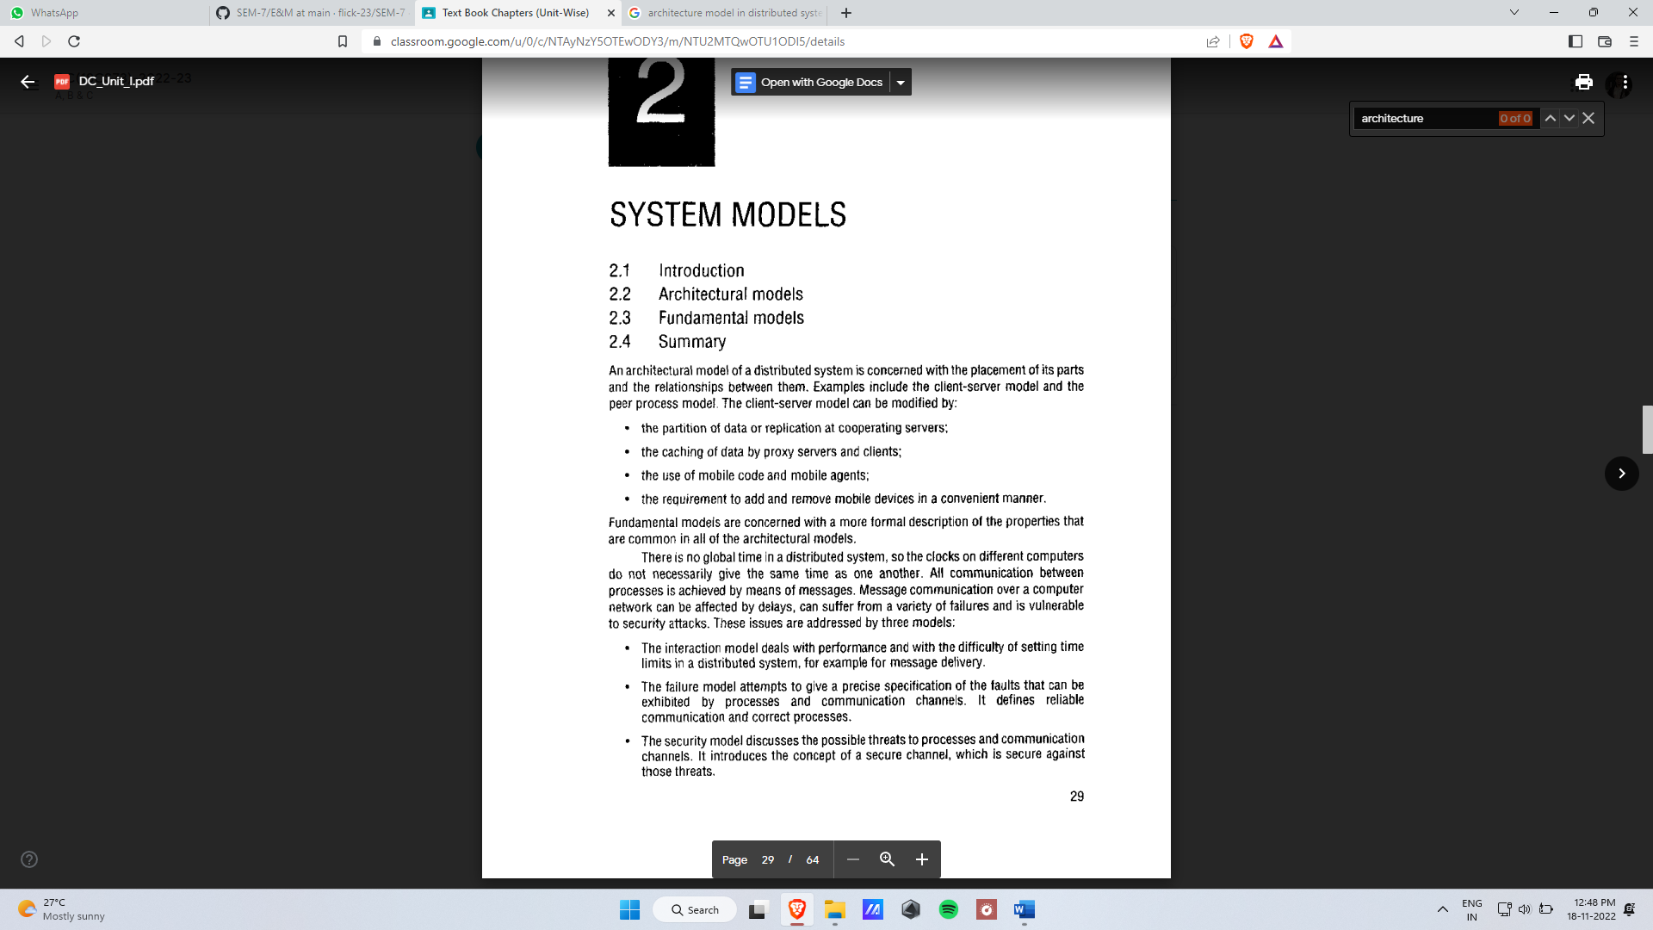

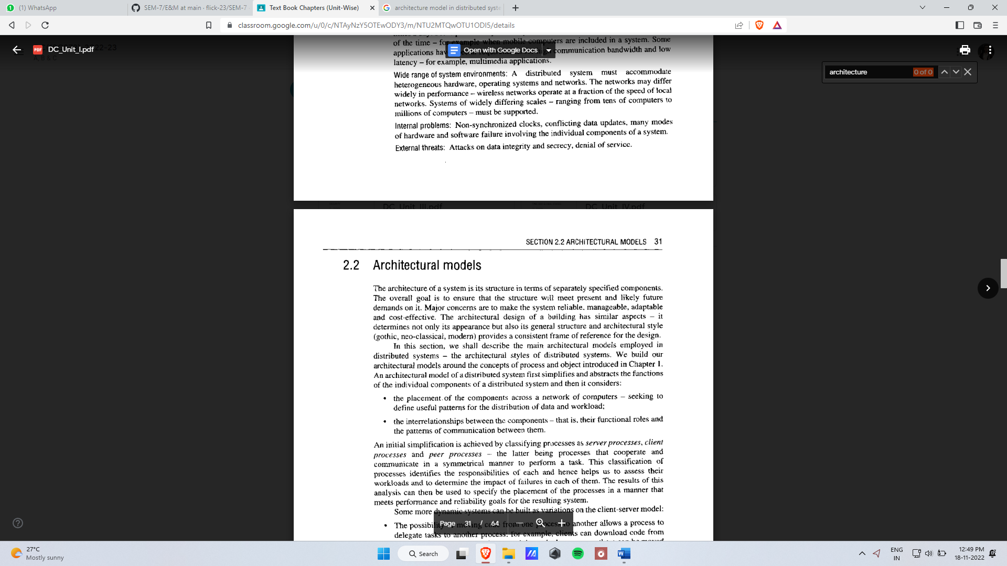

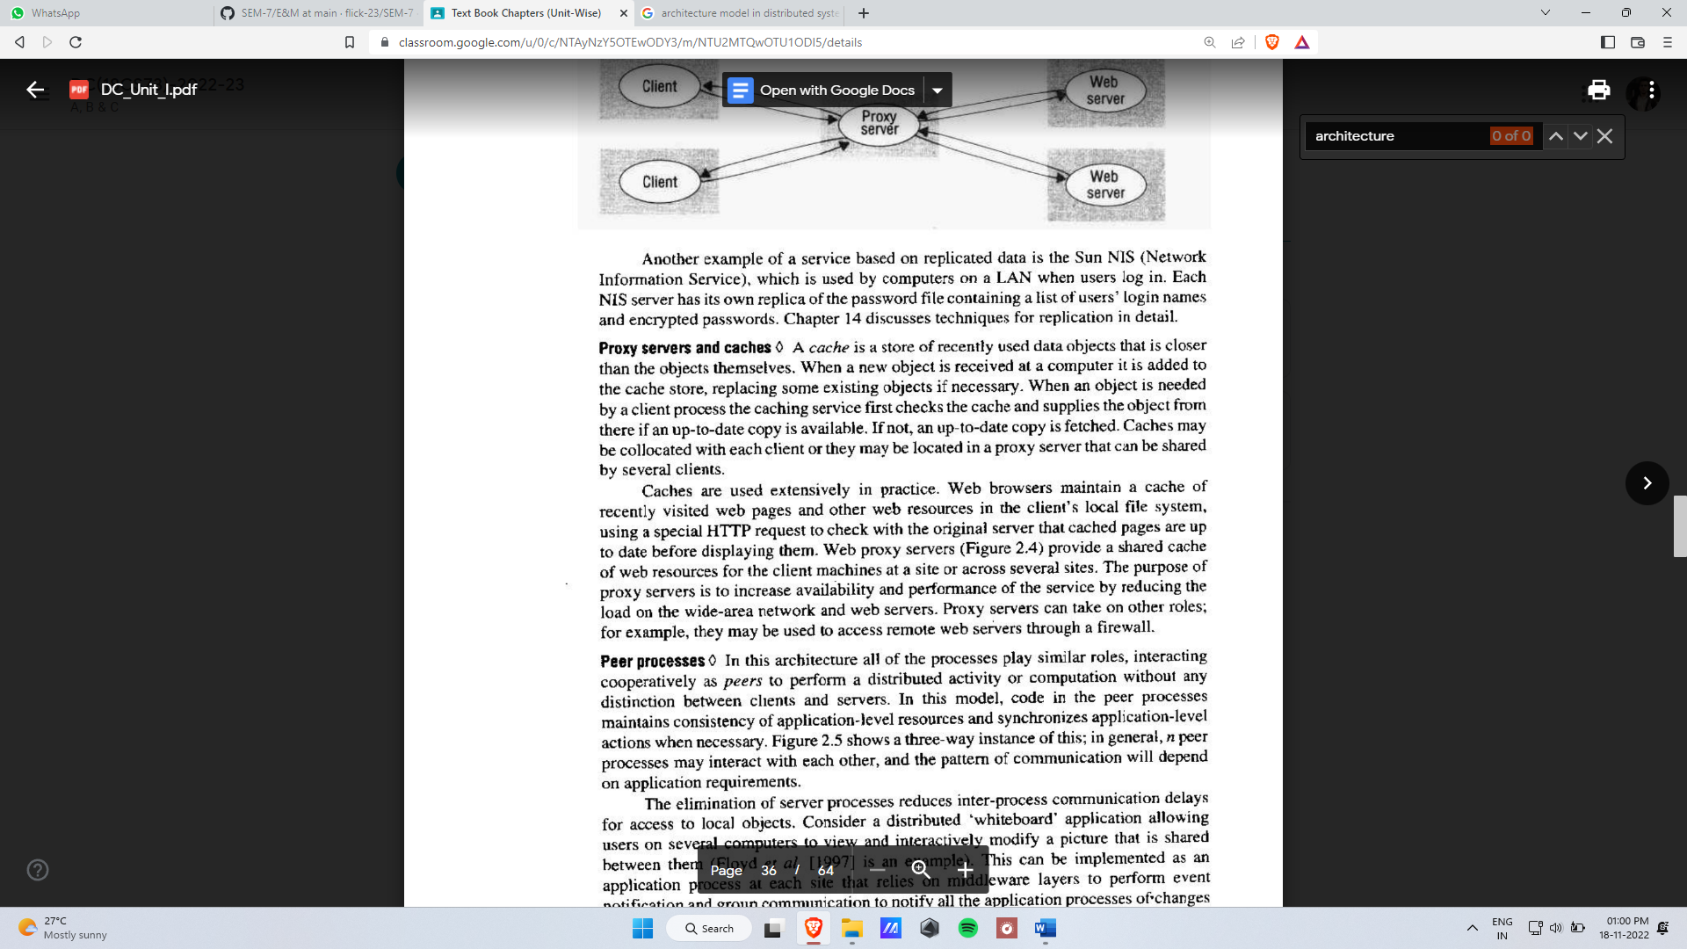

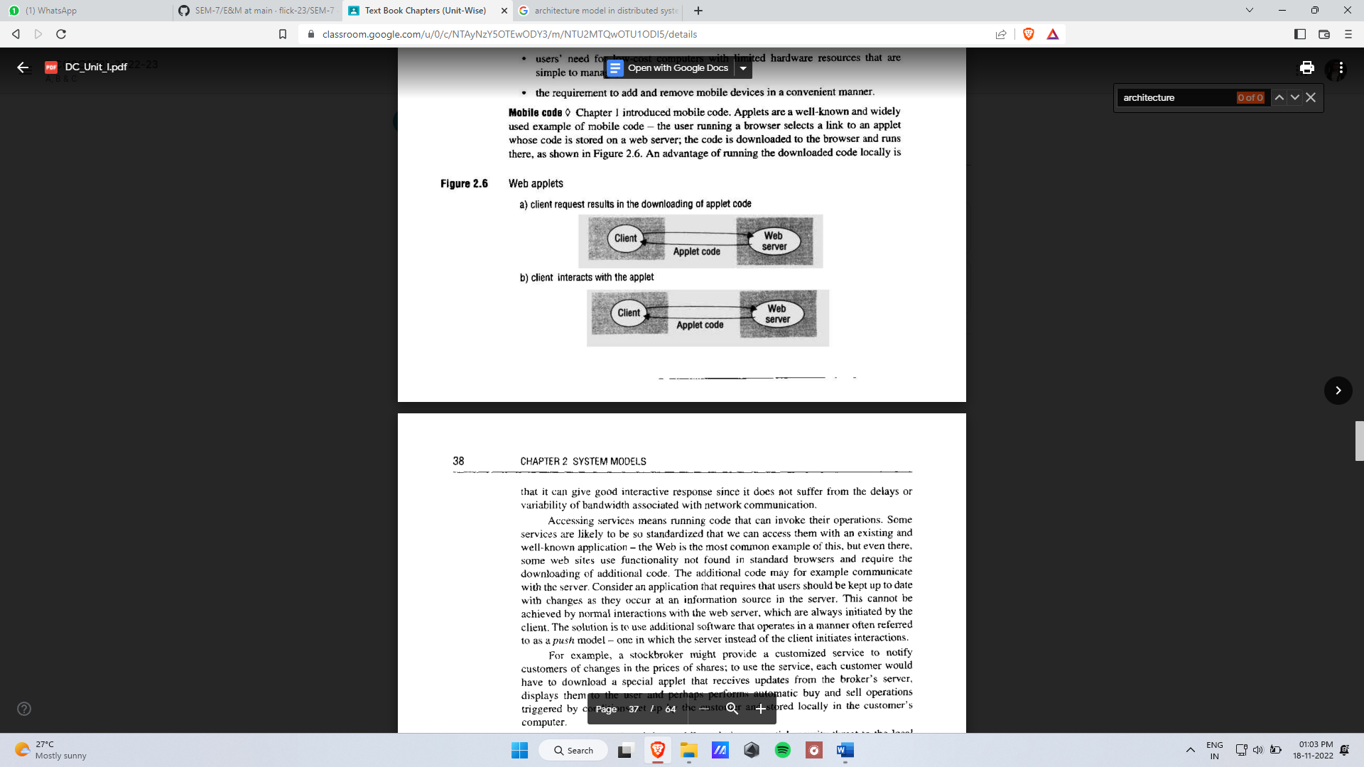

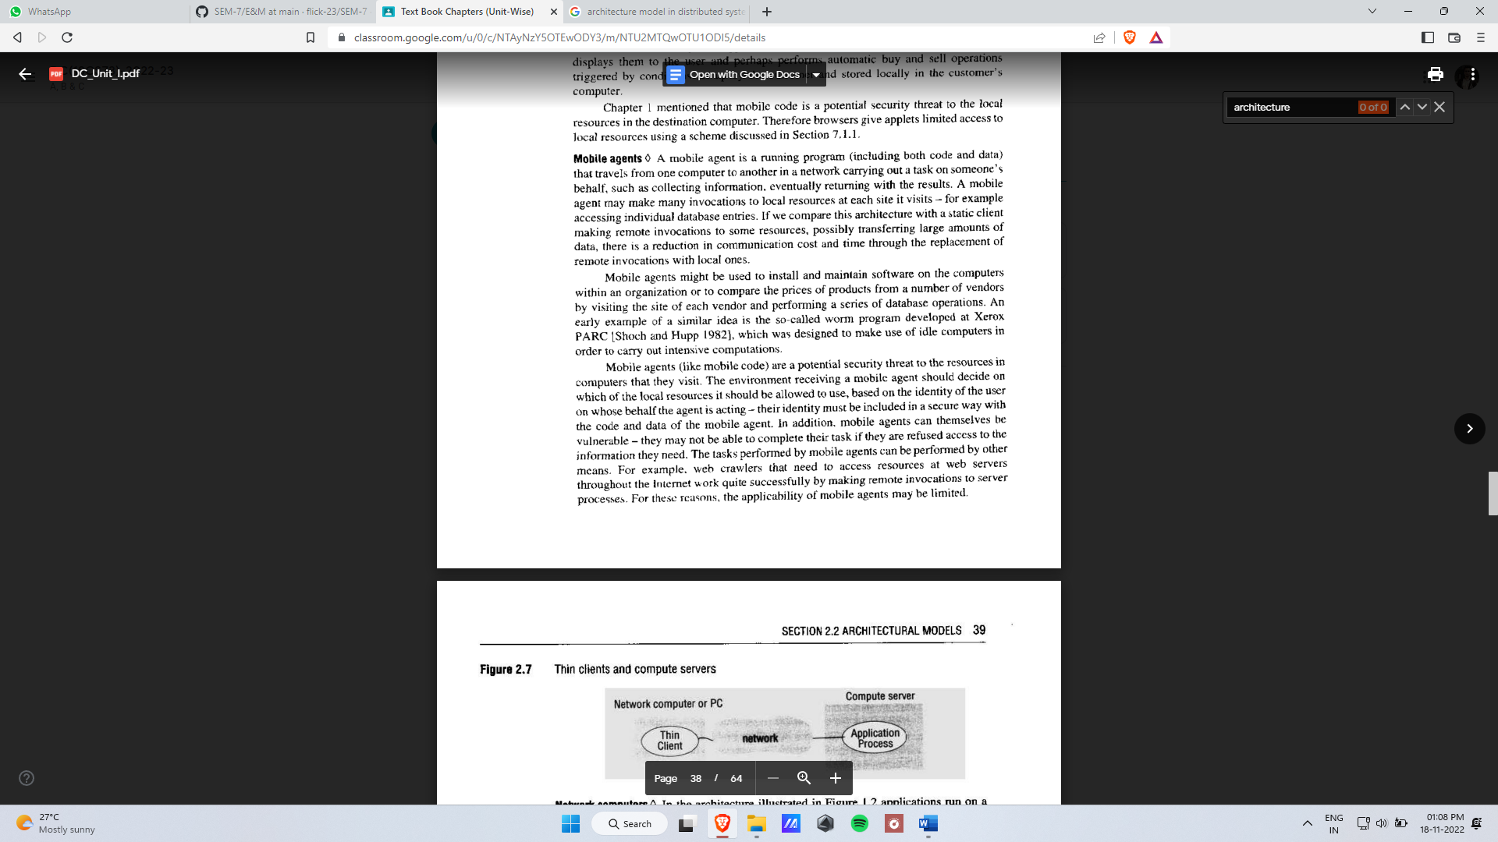

**2**. Summarize the following design requirements for Distributed Architectures ;

1. Performance Issues ii) Quality of Service

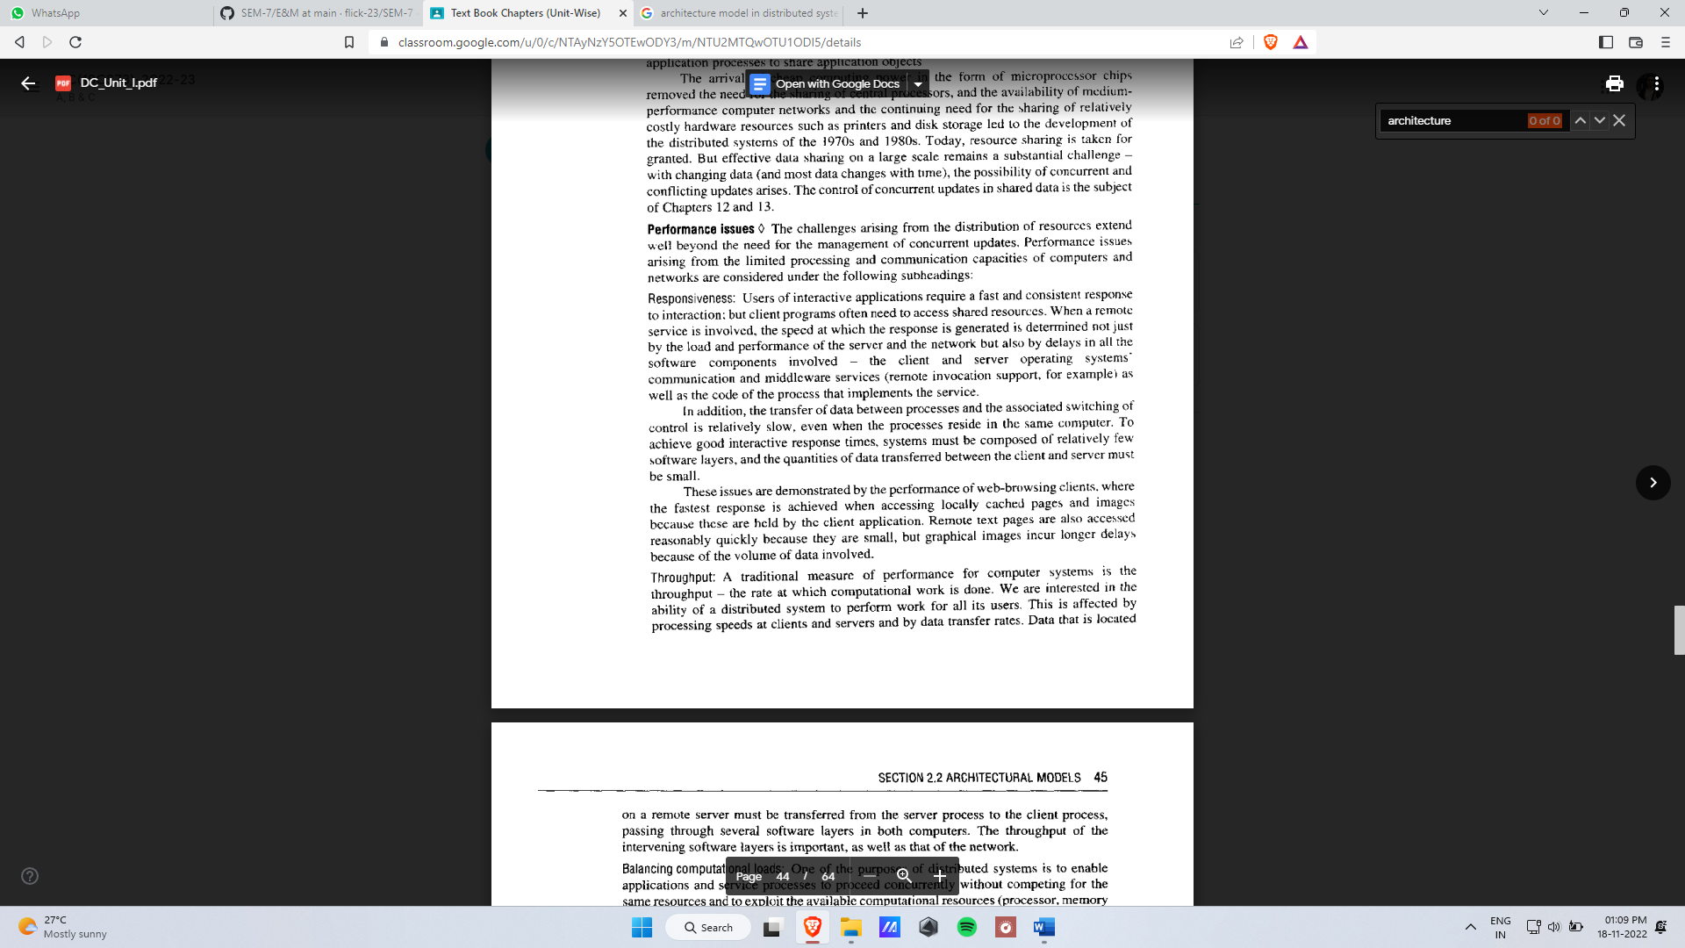

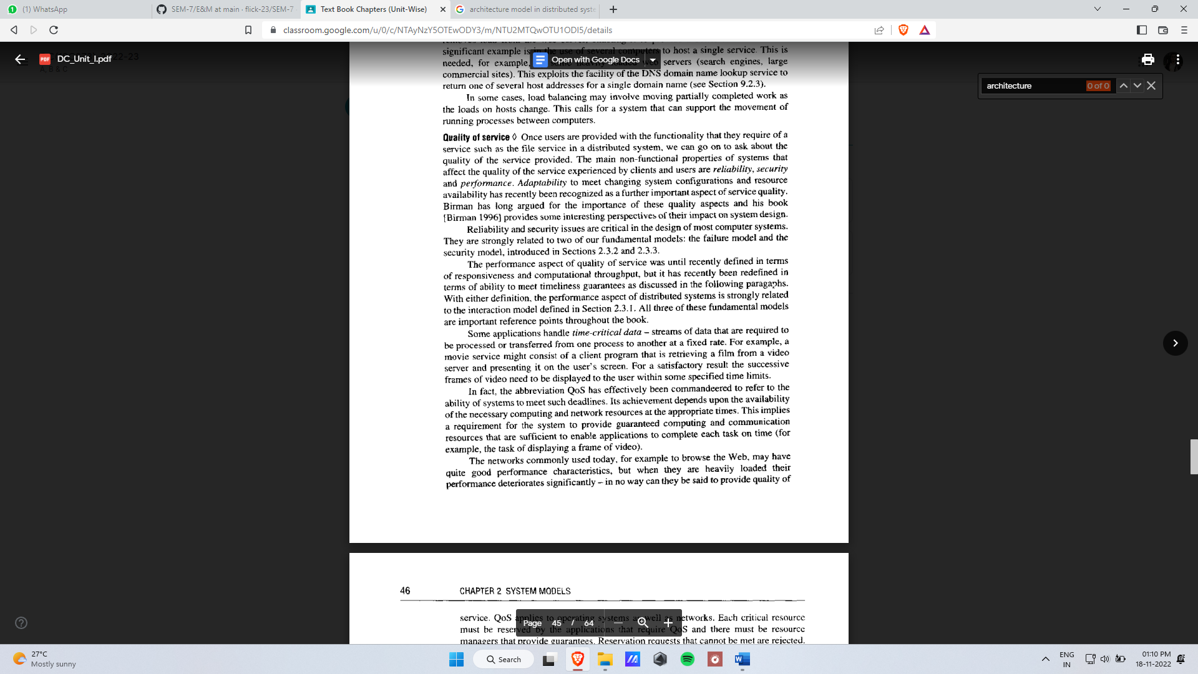

**3**. Explain the Failure Model. With the help of a tabular column describe the various classes of Arbitrary, Omission & Timing failures

**UNIT-II**

**INTER PROCESS COMMUNICAITON**

1. Explain the characteristics of IPC & With a neat diagram explain sockets
2. Compare & Contrast between Synchronous & Asynchronous communication in the context of IPC.

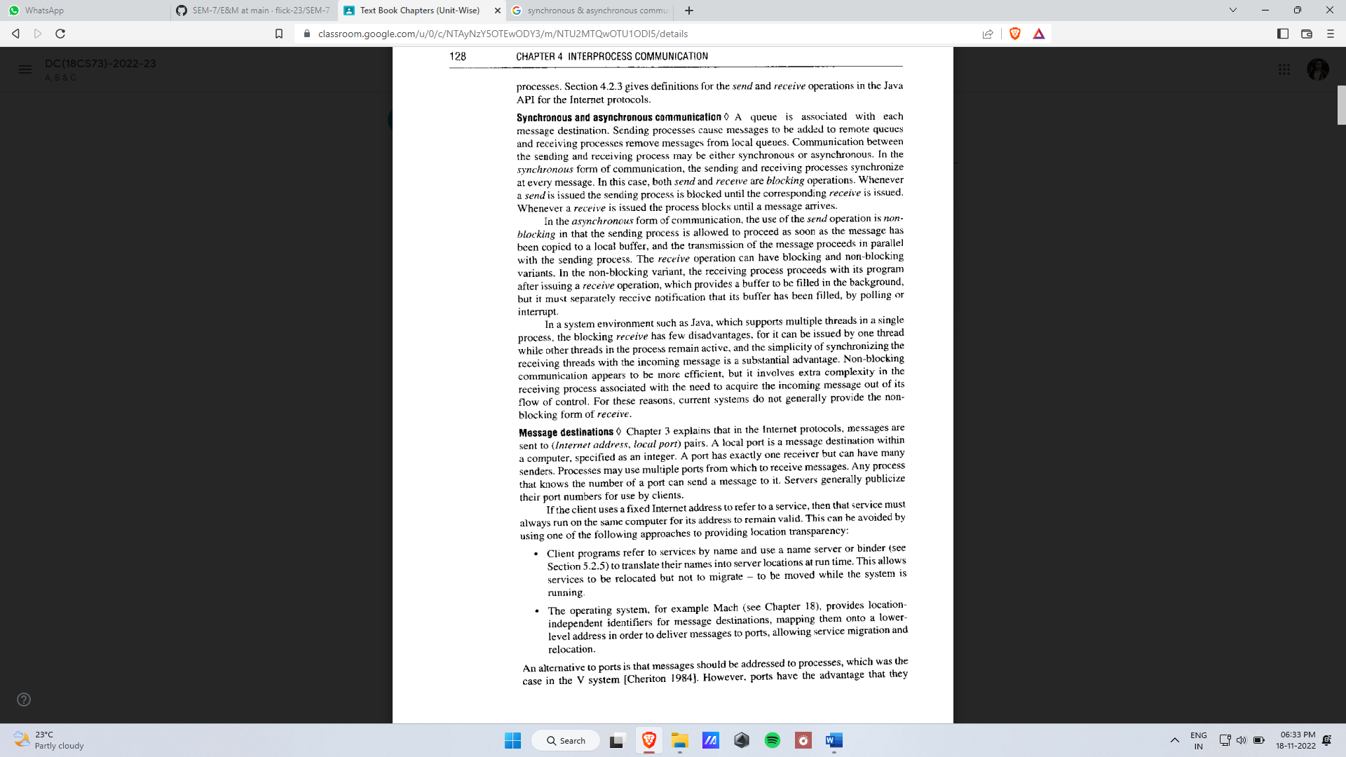

1. Explain Java API for the following.

* UDP datagrams
* TCP streams

1. Discuss issues relating to datagram communication.
2. Discuss the Characteristics and issues related to stream communication.
3. Define marshalling and unmarshalling.
4. Explain CORBA CDR with an example

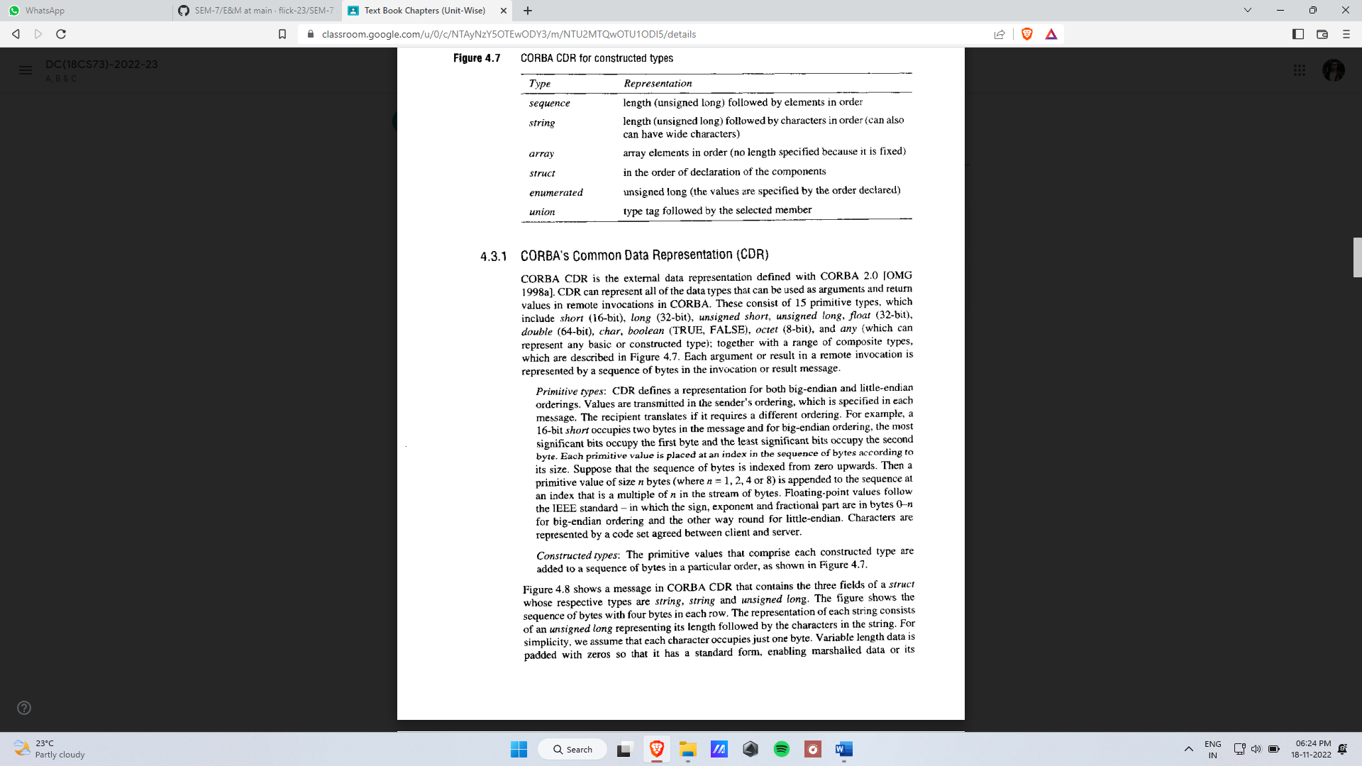

Example:

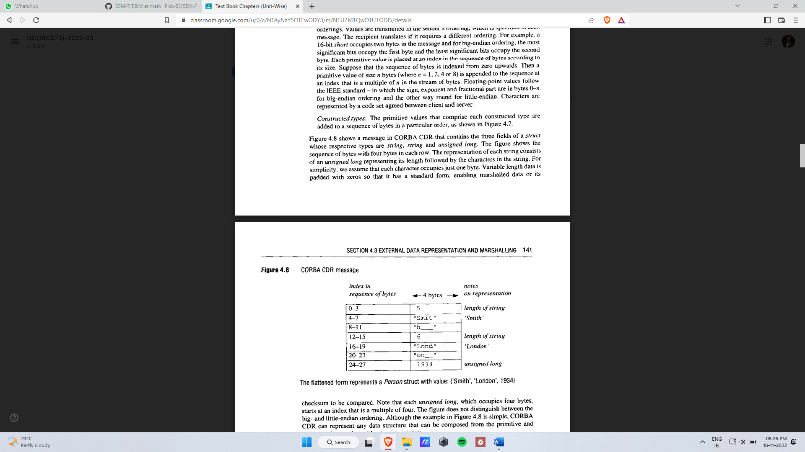

1. Explain Java object serialization with an example.
2. Define Marshalling. Construct a marshalled form that represents a Organization with instance variable values :{ ‘KLSGIT’,’BELGAUM’, 1979, 590008} by using CORBA-CDR & Java Serialization.
3. Analyze the failure model of Request/Reply protocol in client-server Communication using UDP

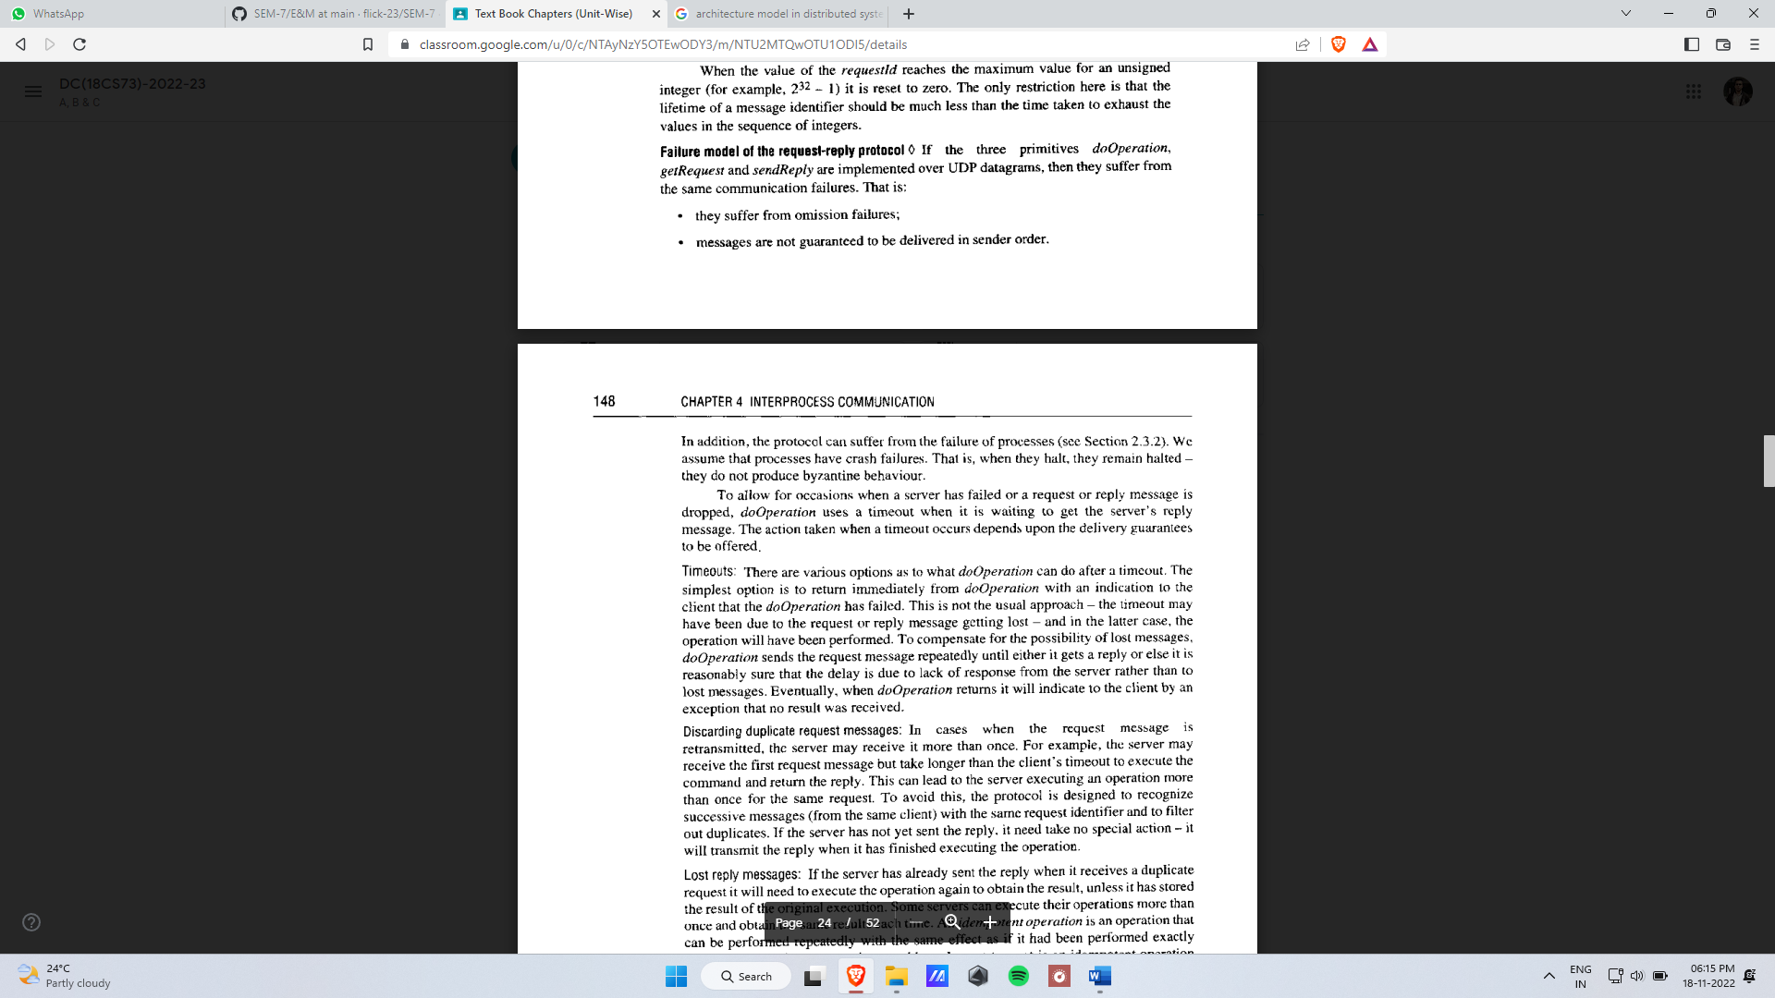

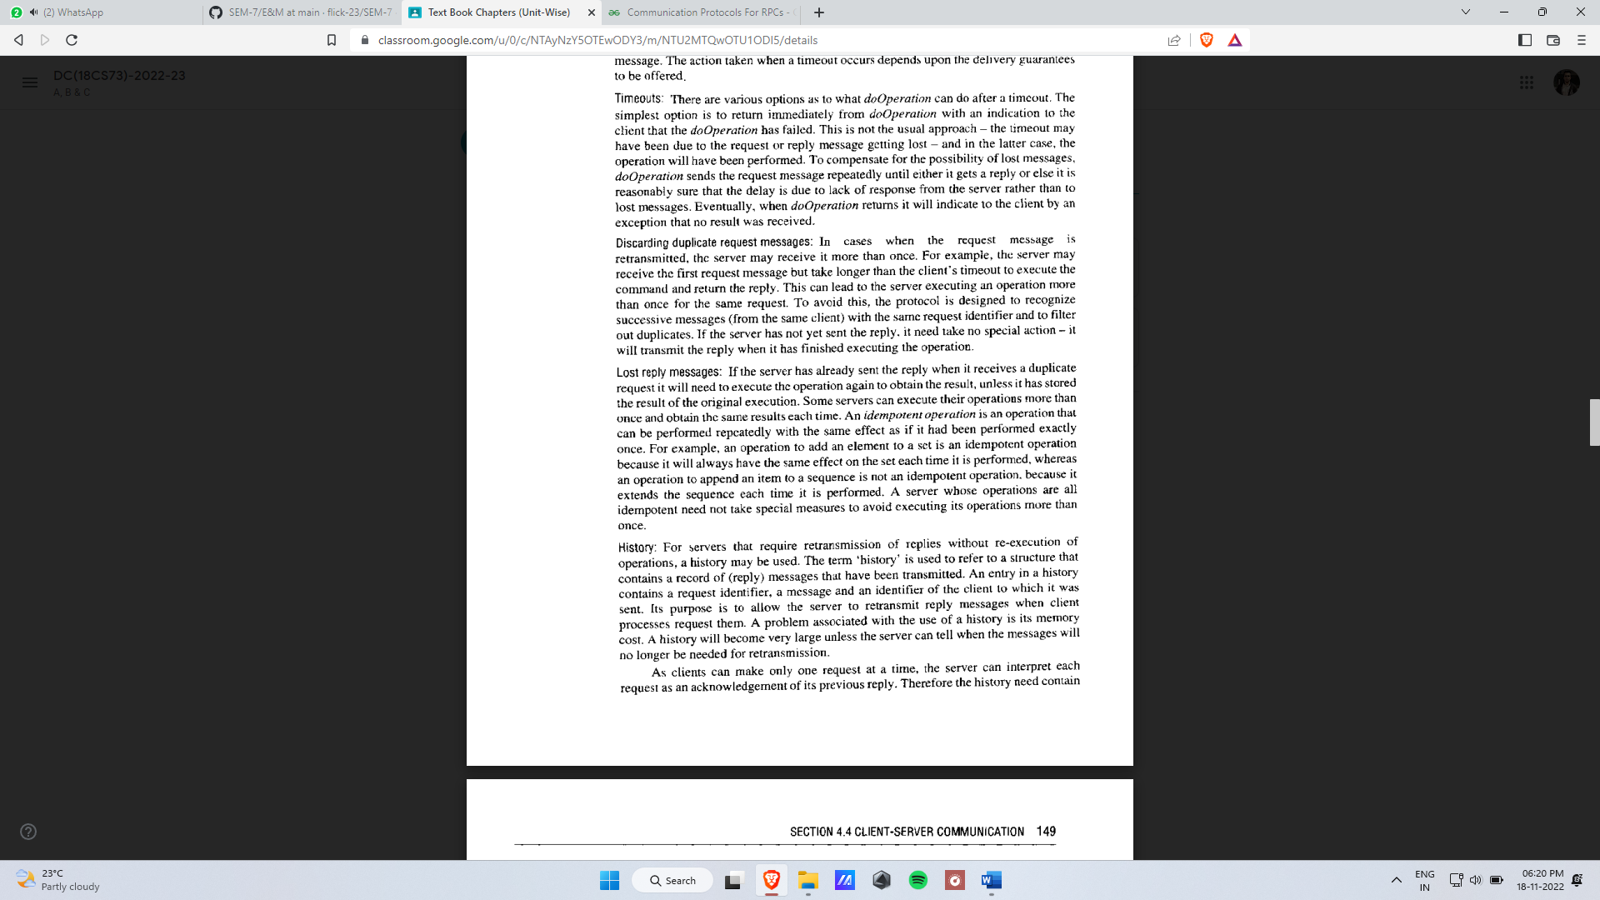

1. Discuss the drawbacks of UDP over TCP stream to implement the request-reply protocol
2. Explain request-reply communication with the neat diagram and specify the operations of the same.
3. List and explain RPC exchange protocols.
4. Explain HTTP request and reply message format.